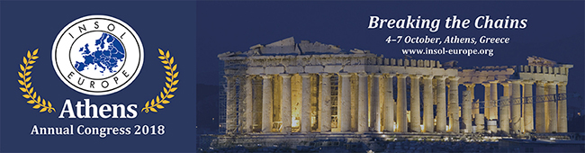

INSOL EUROPE Annual Congress 2018,
Athens, Greece – Registration now open!

We are delighted to announce that registration is now open for our Annual Congress in Athens from 4-7 October 2018. Just by saying the word “Athens” one can’t help but think of the oldest and largest civilization in Europe, stretching back more than 3,000 years. It is therefore a great venue for such an important business event like our 37th INSOL Europe Congress where the main theme will be “Breaking the Chains”.

This year our Technical Programme will feature themes such as 'The Holy Grail of Greek Insolvency Law' and 'Brexit - Are we prepared?'. Our Break-out Sessions will include topics such as 'E-mobility' and 'How to crack down on offshore companies'. These and other subjects will be sure to make for lively discussions that will endure beyond the Congress itself.

“If you are looking to mingle, network and learn from arguably the
highest concentration of European insolvency professionals at one setting,
then the INSOL Europe Annual Congress is the place to be.”
Lynn Harrison 3rd, Partner, Curtis, Mallet-Prevost, Colt & Mosle LLP

Congress Venue
This year the Congress will be held at the Hilton Athens Hotel where we have arranged a special rate for delegates. The hotel is in the centre of Athens, just a short walk from the upmarket district of Kolonaki with steps to Metro station, linking directly to the airport and beyond. There are impressive views of the Acropolis and city from many rooms and the rooftop Galaxy Bar and a Spa with fitness centre, salon, heated indoor pool and a large outdoor pool. Click here to reserve your room at the special rate.

We also have a number of rooms blocked at the Best Western Ilisia Hotel, just 2 minutes’ walk from the Hilton, at a special rate for delegates. These may be reserved by contacting ilisia@ath.forthnet.gr and quoting “INSOL Europe Congress 2018”.

Academic Programme
The Academic Forum of INSOL Europe will also be holding its Annual Conference in Athens from
3-4 October 2018. This year's theme is 'Party Autonomy and Third-Party Protection in Insolvency Law’ and further information can be found here.

Congress Language
The congress will be conducted in the English language.

Annual Congress Video
Find out more about our Annual Congresses by clicking here to watch the video of last year’s Congress in Warsaw (Poland).

Full details of the event and how to register can be found on our website here.
Alternatively, email Caroline Taylor, INSOL Europe Director of Administration.

With thanks to our main Congress sponsor, Dentons (www.dentons.com)

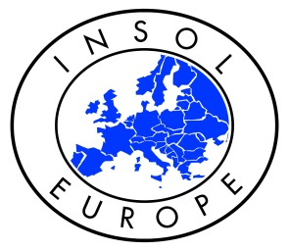

INSOL Europe is an organisation of professionals specialising in insolvency
and business reconstruction and recovery.

Holding international and regional events throughout Europe, we make networking easy and help the exchange of professional experience across borders. At our events delegates can learn about industry developments, participate in academic conferences and network with others in interesting locations. Our events include: Annual Congresses across Europe, Bi-Annual Academic Forums which focus on relevant themes of interest to the practice and academic communities, the INSOL Europe Eastern Countries’ Committee Conference which tackles insolvency issues particularly pertinent to Eastern European countries, an Anti-Fraud Forum, Financial Institutions Group meetings and Turnaround Wing events.

With over 1,250 members across 50 countries made up of lawyers, accountants, judges, regulators, academics and bankers, INSOL Europe makes a significant contribution to the work of European and international official bodies on insolvency, bankruptcy and business recovery. Many members also belong to kindred associations and are members of INSOL International.

Find out more about how to become a member, our events, sponsorship opportunities and more at www.insol-europe.org or contact Caroline Taylor, Director of Administration at CarolineTaylor@insol-europe.org or Tel: +44 (0)115 8780584.

